**Student**

**Login Successful**

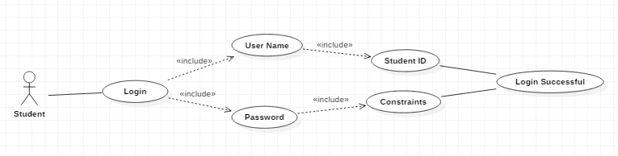

In the initial stage the student must login with his User Name and Password. Username of the student is his SID and Password has few Constraints. Once logged in the student will get a popup as login successful. In the student view once they logged in they can see three modules like Scan QR, View Courses Registered and view attendance percentage.

**Login unsuccessful**

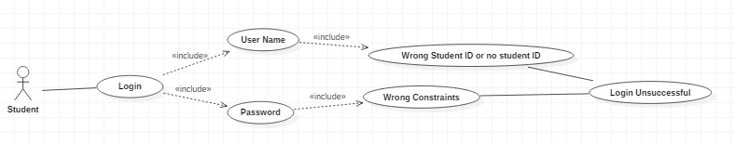

In the initial stage if the student enters wrong username or wrong password they will get a popup as login unsuccessful

**Scanning QR**

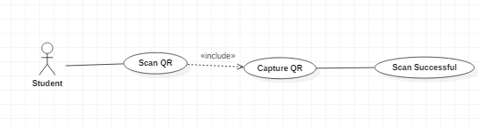

In the scan QR module Student can Scan QR code with his standalone mobile application and later he must capture the QR code for security purpose. After Capturing QR the student gets a popup as Scan Successful

**View Course Details**

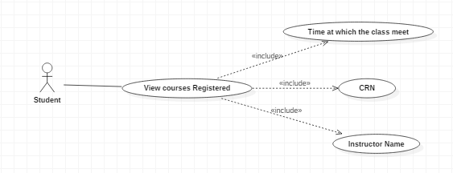

In the view courses registered module students can view their courses which they have been registered for that semester. Within that module they can view Timings of the class, CRN and Instructor Name of that course.

**Attendance Percentage and feedback**

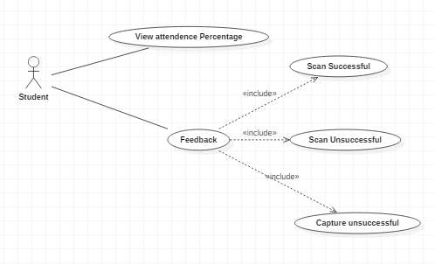

In the view attendance percentage module students can view their attendance percentage and students will receive feedback after scanning and capturing the QR like Scan Successful, Scan Unsuccessful and Capture Unsuccessful.

**Admin**

**Login Successful**

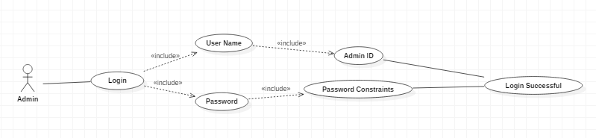

In the initial stage the admin must login with his User Name and Password. User Name of the admin is his AdminID and Password has few constraints. Once logged in the Admin will get a popup as login Successful. In the admin view once he logged in he can see four modules like Manage Course, Manage Student, Manage Instructor and Manage QR.

**Login Unsuccessful**

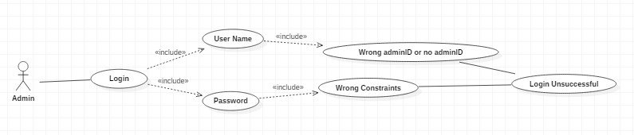

In the initial stage if the Admin enters wrong username or wrong password they will get a popup as login unsuccessful.

**Manage Course**

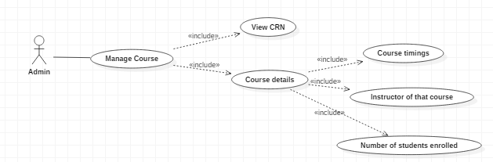

In the Manage Course Module the admin can view CRN and Course details. In the Course details the admin can check the course timings, instructors of that course and number of students enrolled to that course

**Manage Student**

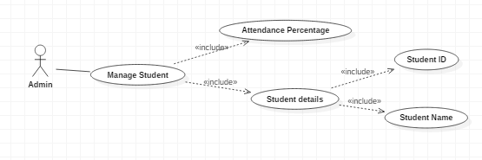

In the Manage Student module the admin can check the attendance percentage of each student and also he can see the student details like Student ID and Student Name

Manage Instructor

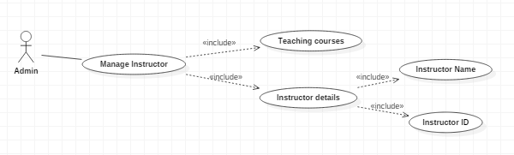

In the Manage Instructor module the admin can view what all courses the instructor assigned with during that semester and also he can check the instructor details like instructor name and instructor ID

Manage QR

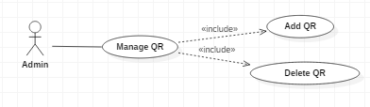

**Instructor**

Login Successful

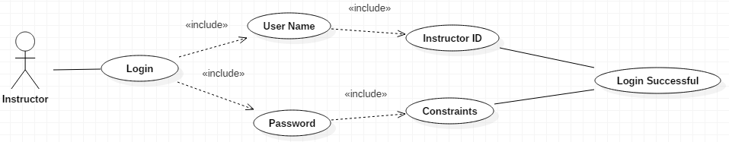

In the initial stage the Instructor must login with his User Name and Password. User Name of the admin is his Instructor ID and Password has few constraints. Once logged in the Instructor will get a popup as login Successful. In the Instructor view once he logged in he can see four modules like Manage Course, Manage Student and Display QR.

Login Unsuccessful

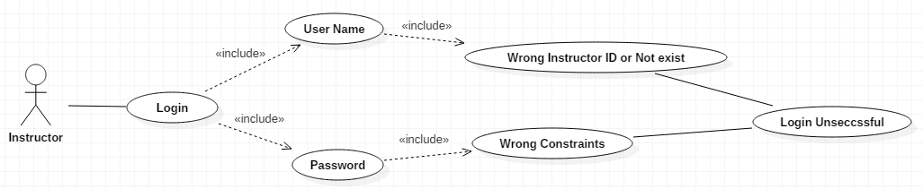

In the initial stage if the Instructor enters wrong username or wrong password they will get a popup as login unsuccessful

Display QR code

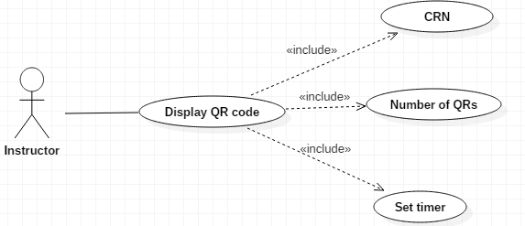

In the Display QR code module, the instructor can display a unique QR code based on CRN and this QR code will be active for the time that he/she had chosen in the ‘set timer field’

Manage Students

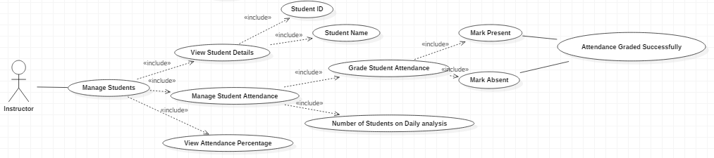

In the Manage Students Module the instructor can view student details like student ID and student name, Manage student Attendance and View Attendance percentage of each student. In Manage student attendance the instructor can grade student attendance and he can view number of students present on daily analysis.

Manage Courses

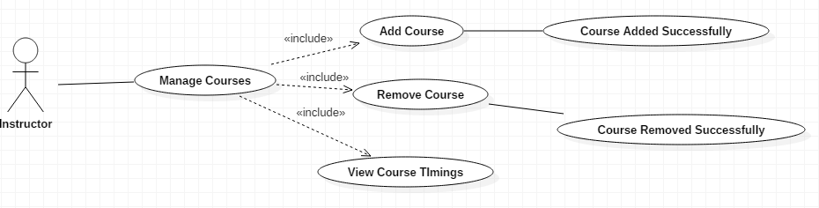

In the Manage Courses module Instructor can add course, remove course and view course timings. If the instructor add course he will get a popup as course added successfully and vice-versa.